M. E. S. College of Arts, Commerce and Science
‘Vidyasagara’ Prof. M.P.L. Sastry road, 15th cross, Malleswaram, Bengaluru - 560003
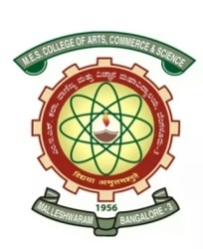
NAAC accredited with ‘A’ grade
Post Graduate Department of Mathematics
“Matribhasha Diwas” on 20-02-2020
This day is celebrated as International Mother Language Day to bring awareness of liguistic and cultural traditions throughout the world.
The following programmes are arranged:
- Display of Books in Matribhasha,
- Lecture Competetion,
- Reading of Kannada books.

Prof. Achala L. Nargund Dr. Janardhan
P. G. Department of Mathematics Principal

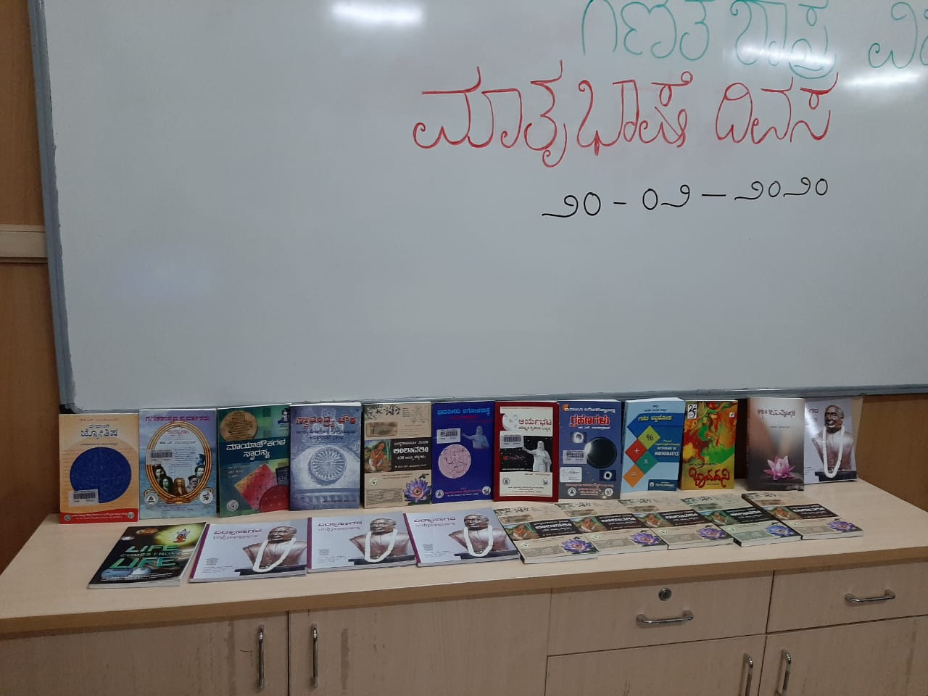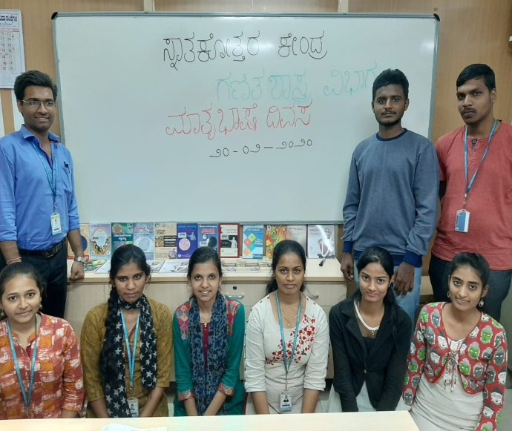

Report

The Post Graduate Department of Mathematics of M.E.S. College of Arts, Commerce and Science celebrated Matribhasha diwas on 20/02/2020. Many Kannada books authored by Dr. S. Balachandra Rao, Shylaja and Shakuntala Devi on various topics of Mathematics, Physics, Astrophysics and Astrolonomy were exhibited in the department. Students read extracts from these books. Students also took part in the lecture competition organized by the department. The topic was “Applications of Mathematics in your Matribhasha.”

